| Google Classroom | Version: <1.0> |
| --- | --- |
| Use-case-Realization Specification: Complete Assignment | Date: <05/Dec/21> |
| <document identifier> | |

Revision History

| **Date** | **Version** | **Description** | **Author** |
| --- | --- | --- | --- |
| <05/Dec/21> | <1.0> | <Initial version> | Bui Hoang Quan |
| <07/Dec/21> | <1.1> | <Edited version> | Bui Hoang Quan |
|  |  |  |  |
|  |  |  |  |

**Google Classroom**

**Online Learning Platform**

**Use-Case Specification: <Create Class>**

**Version 1.1**

# Manage Profile

## Brief Description:

* This use-case allows users to create google classroom
* Subject: Teachers
* Purpose: Make it easier to manage multiple classes at a time.

# Flow of Event

## Basic Flow

* On the main screen of Google Classroom,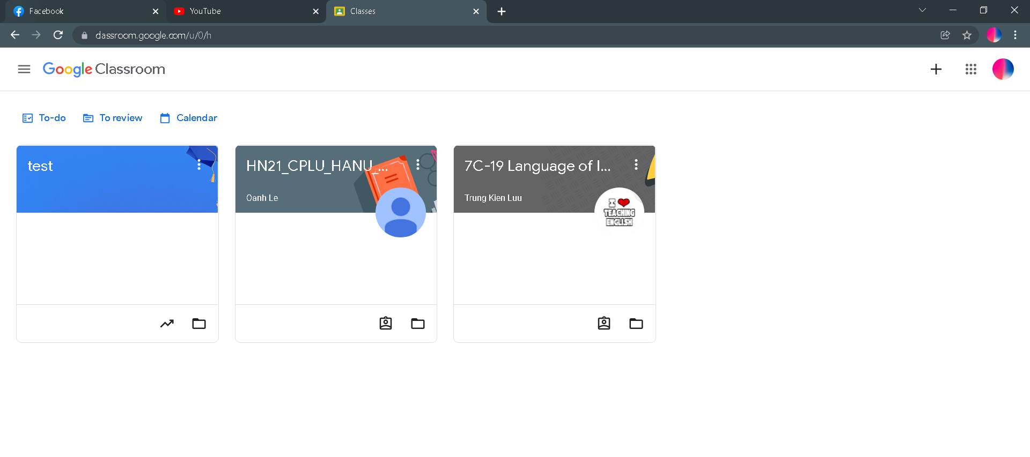click on the  button on the upper right corner to start creating a class. After clicked on it, the button will have a slight shadow effect and a small popup will opened with 2 options “Join class” or “Create class” 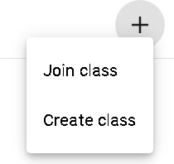. The use case at the moment is to create a class so we will click on the second option “Create class” to start creating a class. The option also has a slight shadow effect when users hover their mouse.
* After pressing the second option, another popup shows up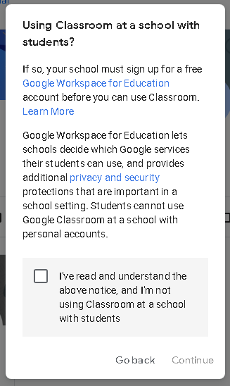 and asking us about the rules and notices while creating and using the classroom. There will be a check box to agree with all the notices, after checked the checkbox, the “Continue” button will transform from unclickable to clickable status and it’s color also changes to blue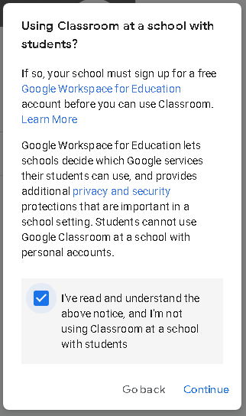. Now we can start clicking on the “Continue” button to go to the next step. A popup appears as soon as we click on the button with the title “Create class”. 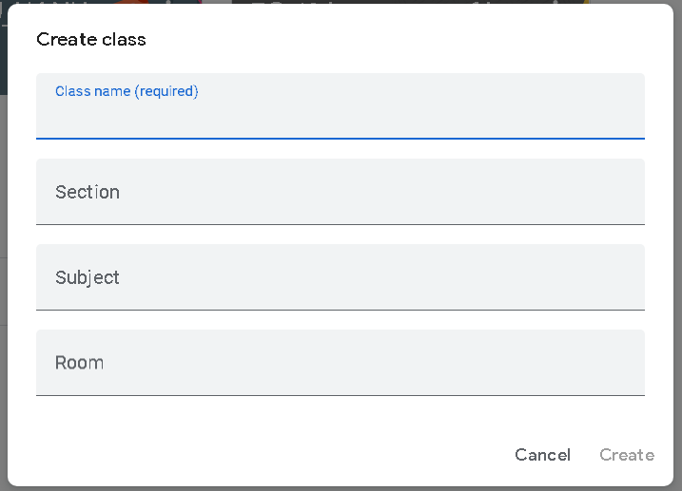 At this point, the users have 4 bars to fill in “Class name” which is required, “Section”, “Subject” and “Room”. Clicking on one bar will make the title of the bar smaller and change it’s color to blue for editing, now users can fill and edit the basic information of the class as they want. After finishing the “Class name” bar, the “Create” button turns blue and now it’s clickable, the process to create class after clicking on it might take a few seconds. And Hola!, this is our class’s main screen and the class creating process was successful. 